SECTION B

Instructions for Section B
Answer all questions in the spaces provided. Write using black or blue pen.
To obtain full marks for your responses you should
- give simplified answers with an appropriate number of significant figures to all numerical questions; unsimplified answers will not be given full marks.
- show all working in your answers to numerical questions. No marks will be given for an incorrect answer unless it is accompanied by details of the working.
- Make sure chemical equations are balanced and that the formulas for individual substances include an indication of state; for example, H_{2(g);} NaCl_{(s)}

Question 4 (5 marks)
A VCE student designed an experiment to calibrate a bomb calorimeter. To do this, a current of 3.00 A was passed through the calorimeter at a potential difference of 1.80 V for 2 minutes and 30 seconds. The calorimeter contained 80.0 g of water at 18.50ºC.
70% of the heat from the electric current was transferred to the water.

- Explain why only 70% of the heat transferred to the water?
1 mark

- Calculate the expected temperature increase during the calibration process.
3 marks
- Calculate the calibration factor for the calorimeter.
1 mark

SECTION A: Multiple-choice questions
Question 9
The sequence of the following peptide is:
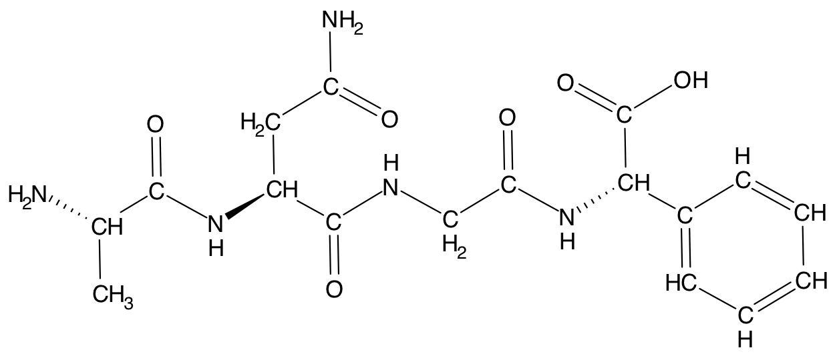
- alanine, glycine, asparagine and phenylalanine
- alanine, asparagine, glycine and phenylalanine
- phenylalanine, glycine, asparagine and alanine
- asparagine, glycine, alanine and phenylalanine

Question 10
When molecular iodine, I₂, reacts with an unsaturated fatty acid, one molecule of iodine adds across each carbon to carbon double bond in the fatty acid. If 0.250 mol of a particular fatty acid reacts with 190 g of I_{2,} the fatty acid could be:

- arachidonic
- linoleic
- linolenic
- palmitoleic

Question 11
The complete combustion of 0.5 mol of sucrose (C₁₂H₂₂O₁₁) in excess oxygen will result in

- 198 g of water
- 198 g of carbon monoxide
- 99 g of water
- 99 g of carbon dioxide

Question 12
Which of the following best describes the chemical bond that connects the two biological molecules?

Biological molecules Chemical bond
- alanine-glycine amine bond
- thyamine-adenine ether bond
- glucose-galactose amide bond
- glycerol-lauric acid ester bond

SECTION B
Question 2 (12 marks)
Saliva contains the enzyme amylase, also called ptyalin, which is capable of breaking down starch into simpler sugars such as maltose.

- Name the type of bonding that holds the two glucose monomers together in maltose.
(1 mark)
- Why can amylase catalyse the breakdown of starch but cannot catalyse the breakdown of cellulose despite both substances being made of glucose?
(1 marks)

- The graph below shows the results of a study into the effect of pH and temperature on the activity of amylase.

- At what temperature does amylase have maximum activity?

- Why does increasing the temperature from the optimum value cause a decrease in the activity of the enzyme?

- Complete the table below by listing the type of chemical bonding responsible for maintaining the structure of a protein.

Protein structure | Type of chemical bonding
Primary structure
Secondary structure
Tertiary structure

- If at 50°C the enzyme was able to catalyse the production of 300 millimole of glucose per milligram of enzyme (mmol glucose/mg amylase) in 30 minutes. Calculate the mass of glucose (Mr = 180) produced in 1 hour by 10.0 mg of amylase at 40°C.
(1 + 1 + 3 + 5= 10 marks)

